|  |
| --- |
| BCIS301-AMIC700 |
| Factors that affect Technological Implementation |
| Assessment 2 |

|  |
| --- |
| Kieran Abelen, Allen Zhang, Jerry Wang  10-14-2019 |

Contents

Introduction 2

Structure 3

Methodology 4

Data Analysis 5

Discussion 6

Outcome 7

Conclusion 8

Test 9

# Introduction

# Methodology

# Data Gathering

## Data used

We agreed that we would use every excerpt since the analysis might not be apparent until the gaps are identified. The excerpts need context so long enough to understand was is going on, for example all the bullet points under a heading.

## Validation

All the excerpts have been validated by asking if this is a true gap. The gap does not have to be a negative or problem aspect of an excerpt but could be a positive aspect.  
We where trying to identify what is important about each technology implementation.  
If there was something negative or positive what was the culprit or underling theme.

## Gaps: Meta-Factor

All gaps need to simple and explain as issue from a current solutions or lack of and the final solution. Let’s say the current system is Microsoft and everyone is used to this familiar style, and obvious gap is trying to get used to a new system. The gap is familiarity with best solution being the most familiar.

# Data Analysis

## Intro

The Gap analysis is designed like risk analysis for the planning stages of any project. There will be a list of objectives or goals in any projects and you need to find the gap between the existing state of an objective to its planned outcome or goal.

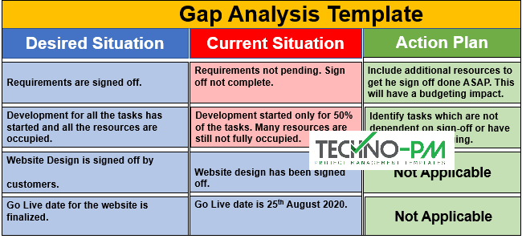

This sets the perfect scene for our analysis since all gaps are not issues or problems with the report, but issues or problems to achieve the objective or goal.

## Quantitively analysis

During the initial data gathering the question is

### **Technology Solution to?**

* Help an IT profession
* Help a software engineering tutor
* Enable the team to work together
* Help the ethics process for projects
* Would attract more networking students
* Help an IT profession
* Set up a WAN
* Preform digital collaborations

These helped identify the correct Gaps in the data; Automation, Communication, Compatibility, Familiarity, Financial, Security and Training.

## Gaps

A new set of questions needs to ask around each gap. This will help set a scene for the Gap analysis since it will give us context around a beginning and final state.

### **A Technological Solution should?**

1. Automate an existing process that is taking too long or is too costly
2. Allows multiple communication functions removing physical barrios like location and technological ones like different calendars.
3. Be compatible with current systems without needing extra solutions.
4. Be familiar with staff so they don’t need any prior training to operate it.
5. Be within the budgeted amount of time and money.
6. Protect any information and be secure when communicate it.
7. Have adequate training built it for any of its new systems.

This is the best-case scenario, so each technological replacement should tick all these boxes.

## Summary

Each report provided by ARA has given us insight into the sorts of issue that arose in its technological implementation/proposal. With this knowledge a list of gaps can be formed along with a list of questions that should be asked to overcome these gaps.

1. Automation
2. Communication
3. Compatibility
4. Familiarity
5. Financial
6. Security
7. Training

These gaps will help inform our tool by rating how successful each technology resolves these gaps.

# Outcome

# Conclusion

# Test

|  |
| --- |
|  |
|  |